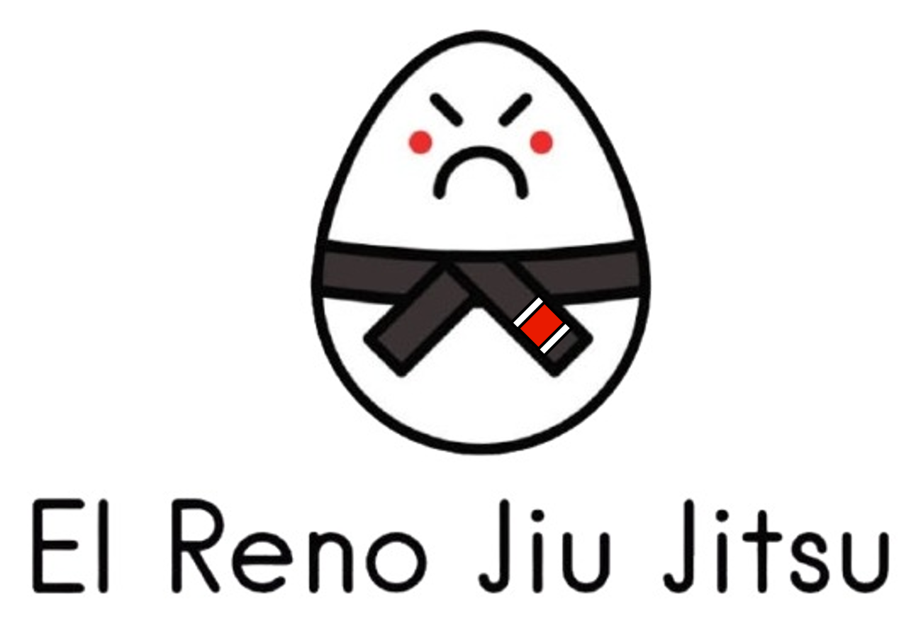

# Payment Authorization Request

I authorize and request El Reno Jiu Jitsu to initiate debt entries to my account. This authorization is to remain in full force and effect until El Reno Jiu Jitsu receives written notification of termination; this notification must be received 15 days or more before my next billing cycle date. If notice is given less than 15 days before the next billing cycle the cancellation will not take place until the following month.

By signing this form, I understand and agree that **there is a strict no-refund policy** for any payments made to El Reno Jiu Jitsu. Once a payment is processed, it is non-refundable under any circumstances, including but not limited to withdrawal from classes, early termination of participation, or non-attendance. I acknowledge and accept this policy as a condition of enrollment.

**Signature:**

I confirm that I have provided accurate information and that I have read and understand the terms of this payment authorization and no-refund policy.

____________________________________________________

Printed Name

____________________________________________________

Child’s Name (if applicable)

___________________________________________________________________________________ Street Number City State Zip Code

__________________________________ ____________________________________________

Phone Number Emergency Contact & Phone Number

____________________________________________________ __________________

Customer Signature Date